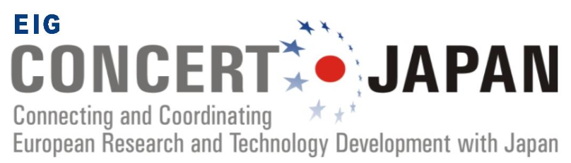

Joint Call on
AI-Powered Robotics for Real-World Applications

Please fill all sections of this document, add the researchers’ CVs and upload it as one PDF file to the EIG CONCERT-Japan Joint Call electronic submission system at:

https://ptoutline.eu/app/eigjapan_jc2026

Please note that only one PDF file can be uploaded. Other file formats will not be accepted by the system. The name of your file will automatically be changed
during the upload process. If you have already uploaded a file before, it will be overwritten by any subsequent file upload.

The deadline for proposal submission is
Wednesday, 22nd July 2026
10:00 (morning) Europe CEST / 17:00 (afternoon) Japan JST

Please make sure that the number of pages you prepare
for each section corresponds to the maximum number indicated in brackets.
Use Arial font in size 11.
Proposals exceeding the given limits will not be accepted.

Project title: Capitalize as a proper title, e.g. as for a book title.
Project acronym:
Keywords: Provide a minimum of 5 keywords for classification and evaluator assignment.
External reviewers: Name 2 to 3 external experts who could review your project with no conflict of interest.
Name and institution of project leader for Japan:
Name and institution of project leader for Europe:
(Underline the principal project leader from the 2 above)
Names and institutions of other project partners:

1. General information

1.1. Short abstract of the project
Please describe briefly the rationale and overall aim of the project and its relevance regarding the aim of the Joint Call (max. 300 words and up to 1 page when including graphs).

1.2. Main objectives of the project
Please describe the overall aim and specific objectives in detail, state of the art, giving when possible quantitative data. Describe also the expected results of the project (max. 300 words and up to 1 page when including graphs).

1.3. The project description
Please explain the project in detail (max. 1200 words and up to 4 pages when including graphs).

1.4. Scientific excellence of the project and the project partners
Please explain what makes up the excellence of the proposal and the consortium, and its innovative aspects (max. 600 words and up to 2 pages when including graphs).

1.5. Project coordination and management
Please describe how the project will be coordinated, and what will be the tasks of each partner (max. 600 words and up to 2 pages when including graphs).

2. Work plan

Please describe the work plan according to the four aspects below (max. 600 words per aspect and up to 2 pages when including graphs).

2.1. Research methodology

2.2. Work plan (timetable / Gantt chart)

2.3. Envisaged types of activities (including main milestones, deliverables and place in case of events)

2.4. Role of each partner

3. Project budget

Type of costs | Partner | 2027 (April~) | 2028 | 2029 | 2030 (~Mar) | TOTAL
Research materials
Personnel costs
Travel*
Living expenses
Organisation of events
Eligible indirect costs
TOTAL

*The team should budget for two EIG CONCERT-Japan in-person workshops in Europe (organized with the other funded teams in the same call and funding agencies). Each team is expected to have at least three members attending each workshop, including representation from both the European and Japanese sides. The Program Secretary will contact the Lead PI to share dates and details for the workshops.

4. Expected impact of project results
Please describe the expected impact of project results below (max. 600 words and up to 2 pages when including graphs).

5. Impact on Sustainable Development Goals (SDGs)

Please describe the relevance and impact of your proposal related to the relevant SDGs. (max. 600 words and up to 2 pages when including graphs).

6. Added value of multilateral cooperation

Please describe the added value of multilateral cooperation below (max. 600 words and up to 2 pages when including graphs).

7. Short CVs of main participating researchers

Please add a short CV of the main participating researchers involved in the proposal, including a list of the five most relevant publications of the last ten years (max. 1 page per researcher).

8. Confirmation letter

This confirmation letter is necessary only in case of additional partners that need to secure their own funding.

------------------------------------------------

