Acronyme du projet / Acronym
Titre du projet (en français)
Proposal’s title (in English)

Table des matières / Table of contents
Pensez à mettre à jour la table des matières avant finalisation de l’annexe scientifique

1. BIOGRAPHICAL SKETCH OF THE PROJECT LEADER 2
2. FOUNDERS AND STAKEHOLDERS PRESENTATION 3
3. WORKPACKAGES AND MILESTONES 4
4. KEY PERFORMANCE INDICATORS 5
5. SWOT ANALYSIS 6
6. REFERENCES 7
7. OTHER INFORMATION IF CONSIDERED RELEVANT 8

BIOGRAPHICAL SKETCH OF THE PROJECT LEADER

LAST NAME | CURRENT POSITION (title, location)
First name
Date of Birth:

EDUCATION/TRAINING
(in chronological order beginning with the latest.)
INSTITUTION AND LOCATION | DEGREE | YEAR OBTAINED | FIELD OF STUDY

Personal Statement and keywords (present subject of interest)
Describe briefly why your experience and qualifications make you particularly well-suited for the role of project leader.

Positions and employment
List previous positions in reverse chronological order.

Awards and Honors
List in reverse chronological order any prizes and/or awards received.

Other information of interest
List for instance major publications, patents, or achievements in terms of innovation.

FOUNDERS AND STAKEHOLDERS PRESENTATION

Brief description of founders and stakeholders.

WORKPACKAGES AND MILESTONES
Please fill the two tables for the first five years of the project.

Workpackages
WP N° | WP acronym | WP Description | Start month | End month | WP Leader
WP 1
WP 2

Milestones
Milestone N° | Milestone name | Expected year of completion | Proposed means of verification

KEY PERFORMANCE INDICATORS
Describe monitoring indicators to measure progress of the business plan and the transformative effect.

SWOT ANALYSIS

Provide a synthesis of the strengths, weaknesses, opportunities and threats of the biocluster within a SWOT diagram.

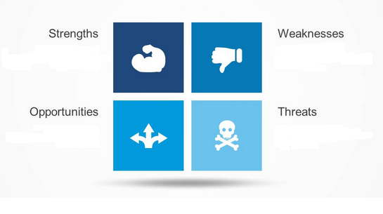

REFERENCES
List of bibliographic references.

OTHER INFORMATION IF CONSIDERED RELEVANT

